Figure: ComicCraft End-to-End Solution Flow
Proposed Solution
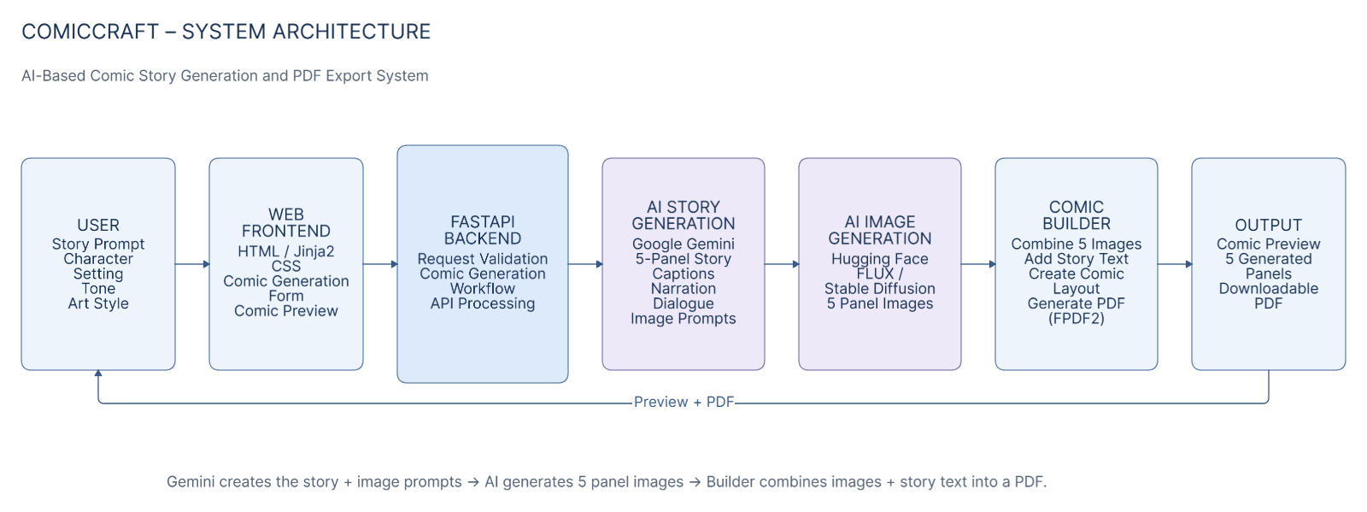
Field | Details
Date | 01 October 2026
Team ID | PNT2022TMID124356
Project Name | ComicCraft - AI Comic Story Creator
Maximum Marks | 5 Marks

Project Proposal (Proposed Solution) Report
ComicCraft is an AI-powered web application that transforms a story idea and creative settings into a five-panel illustrated comic. The workflow combines Gemini-based story planning and expansion, image generation, browser preview and PDF export.

Project Overview
Field | Details
Objective | Reduce manual effort required to plan, write, illustrate and export a short comic by combining these steps in one application.
Scope | Five-panel comic creation from text input, including story outline, narration/dialogue, panel images, preview and PDF export.
Primary Users | Students, beginner creators, hobbyists and users demonstrating generative-AI workflows.

Problem Statement
Field | Description
Description | Creating an illustrated comic manually requires separate story planning, writing, image creation, panel arrangement and document export.
Impact | The fragmented workflow increases effort and slows the transition from an idea to a shareable comic artifact.

Proposed Solution
Field | Details
Approach | Gemini Flash creates the five-panel outline; Gemini Pro expands story text; image generation creates artwork; layout binds content; FPDF2 exports the result.
Key Features | Five-panel generation, AI captions/narration/dialogue, image generation with fallbacks, preview, PDF export, safe download, demo mode and diagnostics.

Resource Requirements
Resource Type | Description | Specification / Allocation
Hardware | Development computer | Python 3.10+; GPU is recommended for local image generation but the project supports CPU paths.
Memory | Runtime memory | Depends on selected image backend/model; no fixed benchmark in source.
Storage | Project/generated artifacts | Source plus JPEGs in static/panels and PDFs in static/exports.
Software | Runtime | Python, FastAPI, Uvicorn, Jinja2, Pydantic, Pillow, FPDF2.
AI Text | Text generation | Google Gemini via google-genai.
AI Image | Image generation | Local Diffusers or Hugging Face integrations with FLUX/Stable Diffusion options.

